Study Information Tab Outside Activity Report Tab Outside Activity Details Tab

STUDY INFORMATION TAB
This section is about the Study you are disclosing on. The last question in this tab addresses if you have outside activities that are RELATED to the PROPOSED RESEARCH. If you answer yes, you will then identify which of your Outside Activities RELATE to the research & you will need to provide an explanation of the overlap & whether your interests will impact the design/conduct/or reporting.
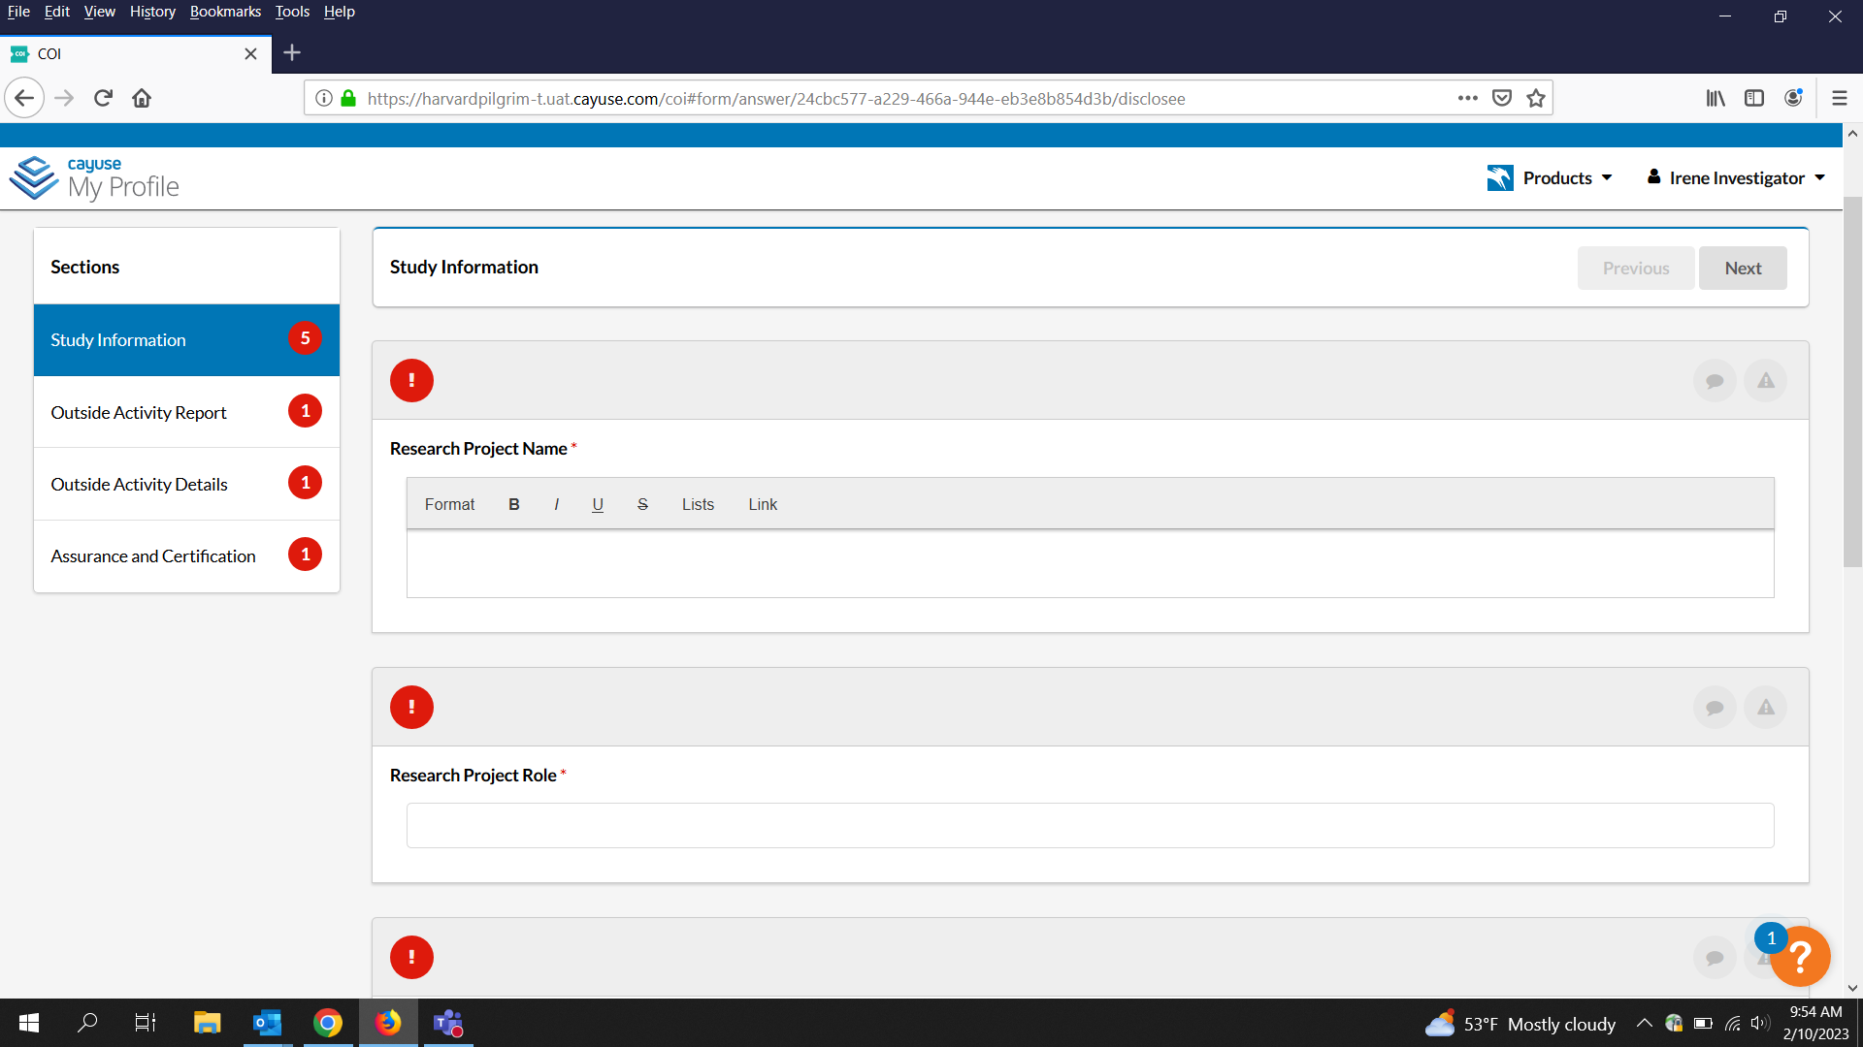
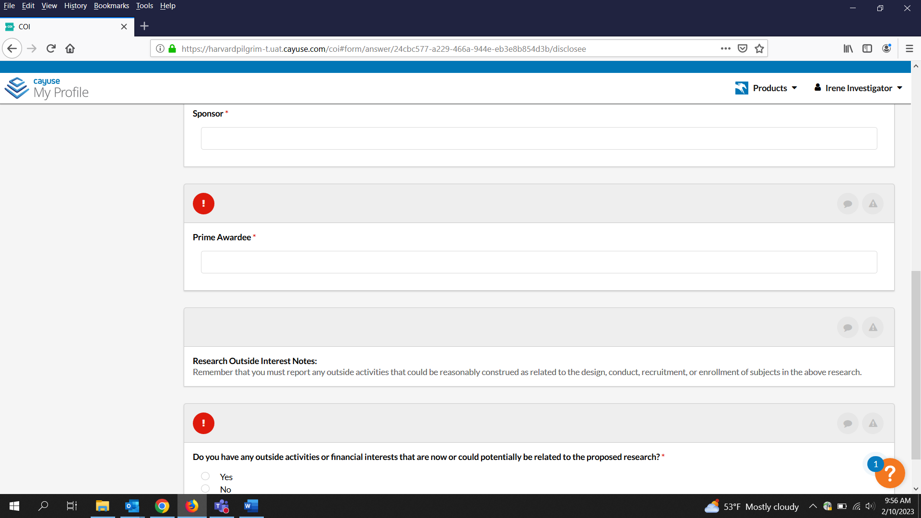
OUTSIDE ACTIVITY REPORT TAB
This section gives you information about what needs to be reported. It reminds you of HPHCI and HMS policies on outside activities. The question in this section asks you to identify if you have outside interests, if you are making updates, or if things are the same from your last report.
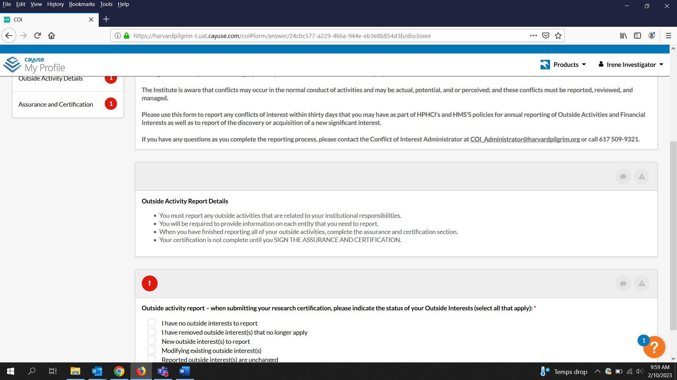

OUTSIDE ACTIVITY DETAILS TAB
This section reminds you of the things you need to report. It provides definitions and examples. If you check “no” here, you’ll move on to the last page for the assurance. If you check “yes”, you will then identify the types of relationships you have with outside entities. If this is not the first time you are disclosing, you will re-identify the types of relationships and then when you move to the next tabs, the details will auto-fill of your previously disclosed outside activity. If they don’t appear, click F5 to refresh. Review the information to be sure everything is current and up-to date before submitting.
